**Ocean Health Index + Tanzania**

**Indicator Review**

**Indicator**: Oil and Gas.

**Aim**: To acquire data/ information on Oil and gas exploration and exploitation activities from experts in Tanzania based on data collected, reports, monitoring and expert opinion.

This exercise seeks to acquire information on the following:

1. Area under exploitation and the year.
2. The activity per region(s) as per figure 1. (Across the entire coastline (if data is available).
3. The frequency of activity occurrence per year.
4. The impact of oil and gas, and related activities on the surrounding biodiversity and ecosystems (i.e. on coral reefs, seagrass habitats; fisheries, on a scale of 1 – 5).

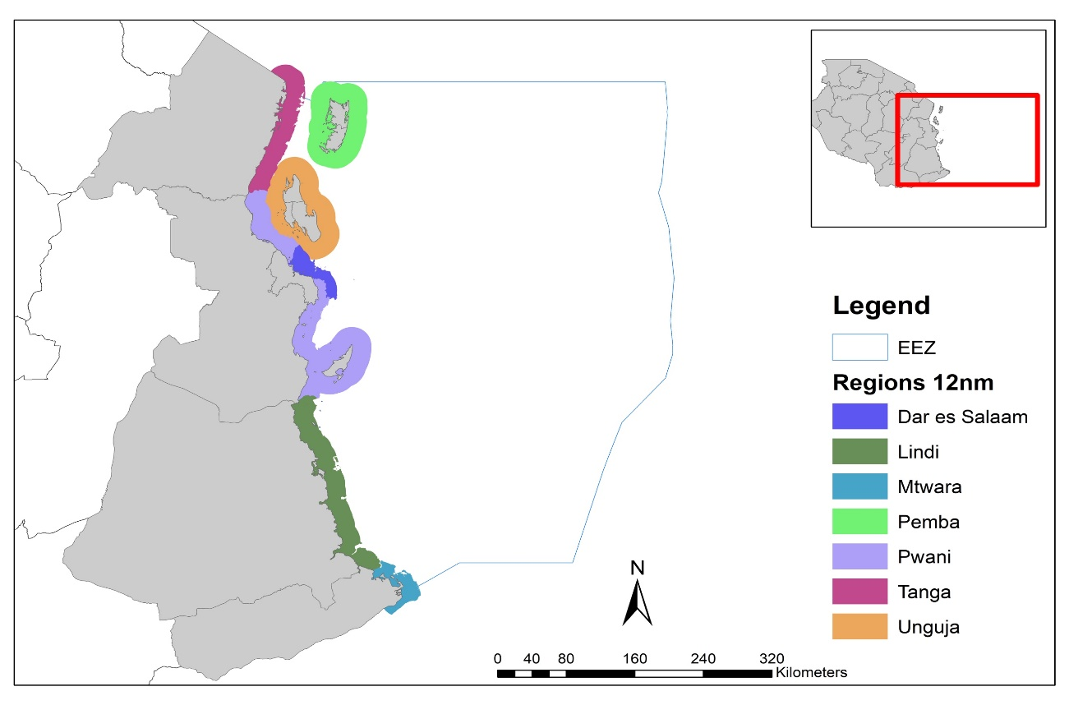

**Figure 1:** Map of Tanzania and Zanzibar delineated into 2 zones; Tanzania and Zanzibar with regions to the 12nm zone.

**Institutional information:**

Name: Matthew Richmond

Designation: Managing Director

Institution: Samaki Consultants Ltd, Dar es Salaam, Tanzania

Date: 3 October 2018

**Table 1**: Data on oil and gas activities per region/ district and catch landed in Tanzania.

|  |  |  |  |  |  |
| --- | --- | --- | --- | --- | --- |
| **Region** (i.e., Dar es Salaam; Lindi; Mtwara; Pwani; Tanga; Pemba; Unguja) | **Target/Affected areas (specific)** | **Year** | **Activity**  **\*Please select the relevant activity.**  On-going extraction activity (ies); Development of infrastructure; Exploration/Seismic tests ; Planning ; No plans /activity) | **Frequency of activity occurrence per year.** | **Rate the impact of the activity on biodiversity (Habitats and species)**  **\*Scale of 1 – 5** |
| Tanga | Inshore waters | 2006 | 0.5 Transition zone seismic | 1 | 4 |
|  | Pemba Channel | 2016 | 0.5 Offshore exploration drilling | 1 | Not certain if it ever took place |
|  | Chongoleani Peninsula | 2019 | 1.0 Proposed Uganda Crude Oil export terminal | 1 | ESIA coming to a close now |
| Dar es Salaam | Offshore Block 7 | 2014 | 0.5 Exploration drilling | 1 | 4 |
|  |  |  |  |  |  |
| Pwani | Offshore Block 5 | 2006 | 0.5 Block-wide seismic | 1 | 4 |
|  | Offshore Block 5 | 2011 | 0.5 Exploration drilling | 1 | 4 |
|  | Offshore Block 6 | 2013 | 0.75 Exploration drilling | 1 | 4 |
|  | Offshore Block 6 | 2014 | 0.75 Exploration drilling | 1 | 4 |
|  |  |  |  |  |  |
| Lindi | Songo Songo Island | 2004 | 0.75 Construction of GPP completed | 1 | 4 |
|  | Songo Songo Archipelago | 2005 | 0.5 Inshore seismic | 1 | 4 |
|  | Songo Songo Archipelago | 2006 | 0.5 Inshore seismic | 1 | 4 |
|  | Songo Songo Island | 2008 | 0.75 Development drilling | 1 | 4 |
|  | Songo Songo Island | 2010 | 0.5 Exploration drilling | 1 | 4 |
|  | Songo Songo Island | 2010 | 0.75 Onshore gas pipeline | 1 | 4 |
|  | Songo Songo | 2016 | 0.75 Construction of 2nd GPP completed | 1 | 4 |
|  |  |  |  |  |  |
|  | Offshore Block 2 | 2010 | 0.5 Block-wide seismic | 1 | 4 |
|  | Offshore Block 2 | 2012 | 0.5 Exploration drilling | 4 | 4 |
|  | Offshore Block 2 | 2014 | 0.5 Exploration drilling | 3 | 4 |
|  |  |  |  |  |  |
|  | Offshore Block 3 | 2005 | 0.5 Block-wide seismic | 1 | 4 |
|  | Offshore Block 3 | 2012 | 0.5 Exploration drilling | 1 | 4 |
|  |  |  |  |  |  |
|  | Offshore Block 4 | 2011 | 0.5 Exploration drilling | 1 | 4 |
|  |  |  |  |  |  |
| Mtwara | Mnazi Bay | 2007 | 0.5 Inshore seismic | 1 | 4 |
|  | Sudi Bay | 2007 | 0.5 Inshore seismic | 1 | 4 |
|  | Offshore Block 1 | 2005 | 0.5 Block-wide seismic | 1 | 4 |
|  | Offshore Block 1 | 2011 | 0.75 Offshore exploration drilling | 3 | 4 |
|  | Offshore Block 1 | 2016 | 0.5 Exploration drilling | 3 | 4 |
|  |  |  |  |  |  |
| Pemba | SW Pemba Island | 2017 | 0.5 Nearshore seismic | 1 | 4 |
|  |  |  |  |  |  |
| Unguja | NW Unguja Island | 2017 | 0.5 Nearshore seismic | 1 | 4 |
|  |  |  |  |  |  |

**Analysis plan**

*On going extraction activity (ies) – 1; Development- of infrastructure 0.75; Exploration/Seismic tests – 0.5; Planning – 0.25; No plans /activity-0.

*Please add any relevant activity (-ies) that have not been captured in point * above.

*Scale: 1 – Highly negative; 2 – Mildly negative; 3 – Moderate impact; 4 – Low impact; 5 – No impact.

*Notes.*

1. *Pre-2002, see TPDC website.*
2. *Since 2006, Songo Songo GPP has been in production, thus “on going extraction”*
3. *Since ca. 2007, Mnazi Bay Ruvula Reninsula GPP has been in production, thus “on going extraction”*
4. *The years shown are indicative or completion of ESIA or ESMP, not always the start of the activity, but close to it.*
5. Management, policy, monitoring and control measures.

Please list the relevant management, policy, monitoring and control measure in place to control and regulate ‘oil and gas’ exploitation activities and rate the effectiveness of these measures.

|  |  |  |
| --- | --- | --- |
| **Measures**  *(Please state the name of the measure; provide a link if possible)* | **Type**  *(State whether it is a report, policy document, law etc. and provide link if available online)* | **Effectiveness rate**  *(Scale: 1 – not effective; 2 – moderately effective; 3 – highly effective)* |
| Mainland Tanzania |  |  |
| Basically the EIA Act controls all. |  |  |
|  |  |  |
|  |  |  |
|  |  |  |
|  |  |  |
|  |  |  |
|  |  |  |
|  |  |  |
| Zanzibar (and Pemba) |  |  |
| The legal document is the Environment Act, though this needs to be confirmed as more recent legislation may now be in place. |  |  |
|  |  |  |
|  |  |  |
|  |  |  |
|  |  |  |
|  |  |  |
|  |  |  |
|  |  |  |
|  |  |  |
|  |  |  |